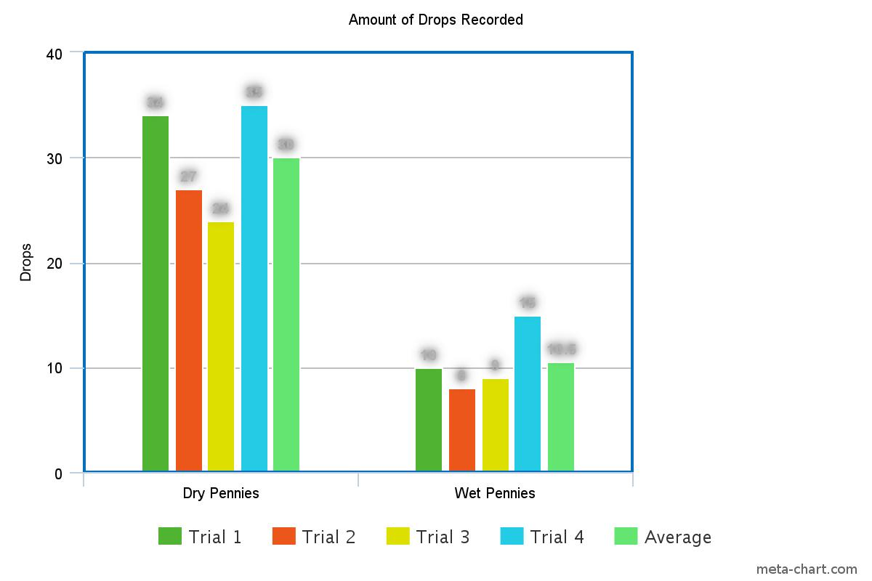Figure 1. Graph of how many drops required to spill for dry vs wet pennies.

|  |  |  |  |  |
| --- | --- | --- | --- | --- |
| Trial 1 | Trial 2 | Trial 3 | Trial 4 | Average |
| 34 drops | 27 drops | 24 drops | 35 drops | 30 drops |

Table 1. The amount of water drops required to spill on the paper recorded with a dry penny.

|  |  |  |  |  |
| --- | --- | --- | --- | --- |
| Trial 1 | Trial 2 | Trial 3 | Trial 4 | Average |
| 10 drops | 8 drops | 9 drops | 15 drops | 10.5 drops |

Table 2. The amount of water drops required to spill on the paper recorded with a wet penny.

Discussion.

In this lab drops of water were placed on a penny with varying surfaces. In table 1 you can clearly see the average is 30 drops. However in table 2 the average amount of drops recorder is just under 1/3 of table 2’s data. This probably happened due to the cohesive properties of water. Cohesion is when the water molecules form bonds with the hydrogen molecules from other water droplets. But since the water molecules at the top are isolated they create stronger bonds so they don’t split off which causes a dome-like shape this is called surface tension. However the reason that the soapy water caused it to spill was due to the soapy water not creating a strong enough bond with the water molecules. This lowered the overall surface tension. But the is the reason for soap when you wash your hands or clean dishes the food or germ particles get washed off because the soap helps break the bonds.

Conclusion.

The hypothesis states that “If the surface of the coin is more slippery then the number of drops will decrease”. The observations recorded displays this. The number of drops recorded with the soapy penny clearly dwarfs the amount recorded for the dry penny. Therefore the hypothesis is accepted, that the number of drops will decrease if soapy water is added to a dry pennies surface. The most obvious conclusion we can come to is that the soap broke up the cohesion between the hydrogen bonds of the water droplets and lowered the surface tension causing the water to not stick together and move freely. The knowledge we have gained from this experiment shows all the things that can be learned from such simple experiments. Just dropping water on pennies can teach surface tension, cohesion hydrogen bonds, etc. Even though this experiment has been concluded there is evermore questions to be asked. For example “Would this work for other liquids?” if so which ones and “Did human error play a major part in this experiment” or even “Could the age of the coin drastically affect the results”. These questions would need to be answered in future experiments with more sophisticated equipment.

"Khan Academy Cohesion and Adhesion of Water." *Khan Academy*. Khan Academy., 7 July 2015. Web. 11 Feb. 2016.

Nave, R. "Surface Tension." *Georgia State-Physics and Astronomy*. Georgia State University, n.d. Web. 11 Feb. 2016